C:\Documents and Settings\npollock\Local Settings\Temporary Internet Files\Content.IE5\RHG31H1S\MC900434537[1].wmf

un

C:\Documents and Settings\npollock\Local Settings\Temporary Internet Files\Content.IE5\I7W23DEZ\MC900434539[1].wmf

deux

C:\Documents and Settings\npollock\Local Settings\Temporary Internet Files\Content.IE5\MP9P9Q7G\MC900434541[1].wmf

trois

C:\Documents and Settings\npollock\Local Settings\Temporary Internet Files\Content.IE5\3RSFHQA3\MC900434543[1].wmf

quatre

C:\Documents and Settings\npollock\Local Settings\Temporary Internet Files\Content.IE5\RHG31H1S\MC900434545[1].wmf

cinq

C:\Documents and Settings\npollock\Local Settings\Temporary Internet Files\Content.IE5\I7W23DEZ\MC900434547[1].wmf

six

C:\Documents and Settings\npollock\Local Settings\Temporary Internet Files\Content.IE5\MP9P9Q7G\MC900434549[1].wmf

sept

C:\Documents and Settings\npollock\Local Settings\Temporary Internet Files\Content.IE5\3RSFHQA3\MC900434551[1].wmf

huit

C:\Documents and Settings\npollock\Local Settings\Temporary Internet Files\Content.IE5\RHG31H1S\MC900434553[1].wmf

neuf



dix

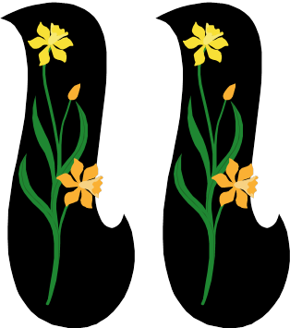

onze



douze

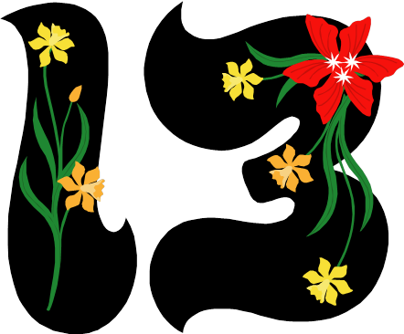

treize



quatorze



quinze



seize



dix-sept



dix-huit



dix-neuf



vingt